  - 2. Reflection Tool with YDI data 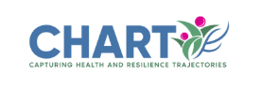
This tool shows how students in your school district are doing in terms of social connection, and provides some prompts for reflection and goal setting. We encourage school-based groups to review this together.

1. Where we are now

On PCES & Youth Engagement:
The most recent YDI report for SD46 can be found here: 2023-2024 YDI Report
Variable | Details | 2024 Data  Black bars show provincial values | Significantly different results*
Peer belonging | Youth’s level of agreement with statements about their sense of belonging to a social group  e.g., “I feel part of a group of friends that do things together” | 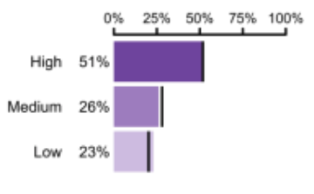 | - 2SLGBTQIA+  - Youth with pre-existing mental health conditions
School belonging | Youth’s level of agreement with statements about their sense of belonging at school  e.g., “I feel like I belong in this school” | 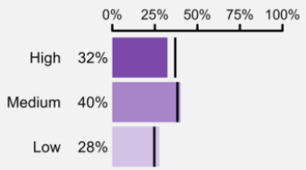 | - 2SLGBTQIA+  - Youth with pre-existing mental health conditions
Supportive adults at school | Youth’s level of agreement with statements about how supported they feel by the adults at their school  e.g., “At my school, there is an adult who really cares about me” | 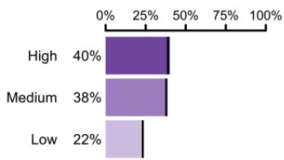 | N/A
Supportive adults in the community | Youth’s level of agreement with statements about how supported they feel by the adults in their community  e.g., “In my neighborhood/community, there is an adult who really cares about me” | 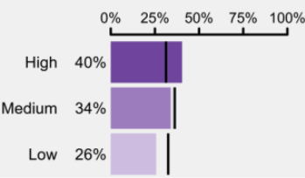
Sense of community belonging | Youth’s rating of their sense of belonging to their community, including geographic community, cultural community, etc.  e.g., “I feel a sense of belonging in my community” and “I know where to go in the community to get help | 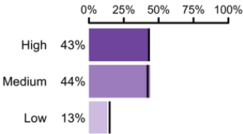 | - Youth with pre-existing mental health conditions
Student voice | Youth’s level of agreement with statements about how much their school includes student voice in decision-making  e.g., “Students are often asked what they think the school is doing well and what the school could do better” | 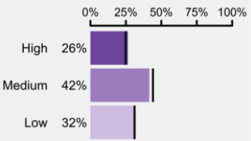 | N/A
School context sub-question | Number of students that say they can talk to teachers/admins about things that matter to them (racism, queerphobia, ableism, mental health stigma) | 45% | N/A
*Sub-populations for which there was a significant difference in the percentage of students who scored/reported “high” on this variable. Demographics that were explored: sexual orientation, gender, pre-existing MH condition. Sub-population analyses were not conducted for all variables.

Strengths: Where are we doing well? What are we currently doing that contributes to these PCEs? (Think of programs, practices, people, services, classes, physical space, leadership, student groups, etc.)

Areas of focus: What areas of social connection or PCEs need improvement? Are there priority subpopulations we want to better support?

2. Where we want to be

1. Identify goals specific to social connection & youth engagement
SMARTIE (Specific, Measurable, Actionable, Relevant, Time-bound, Inclusive & Equitable) Goal(s):

2. Reflection on readiness & resources:
To help us reach our identified goals for social connection...
Where can we find adequate personnel and resources (e.g., leadership, student groups, volunteers, educators, community and health partners) to support these goals?

What infrastructure (e.g., physical spaces, existing supports, curricula etc.) do we currently have that can be used?

How can we build in equity and inclusion as we work towards these goals?

What are some community partners your school can connect with, to support and co-implement the social connection initiatives?
Building social connection in schools is a shared responsibility, and partnerships with community organizations can enhance impact by easing the burden on school staff and fostering more collaborative, supportive environments for students. Some examples of partners are local health authority Healthy Communities and/or Wellness teams, local First Nations & Indigenous organizations, Child and Youth Mental Health (CYMH) teams, Foundry, municipal Recreation Departments, among others.

WHAT ELSE?
  - Youth Engagement Planning Document
  - Toolkit handbook with 14 initiatives
  - Planning Tool

